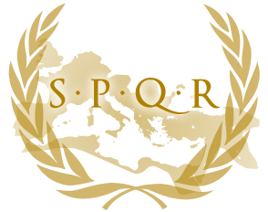Sidney Cowell

TMX High School

5/1/15

Margaret Jones

Greek History Reports

Ancient Rome

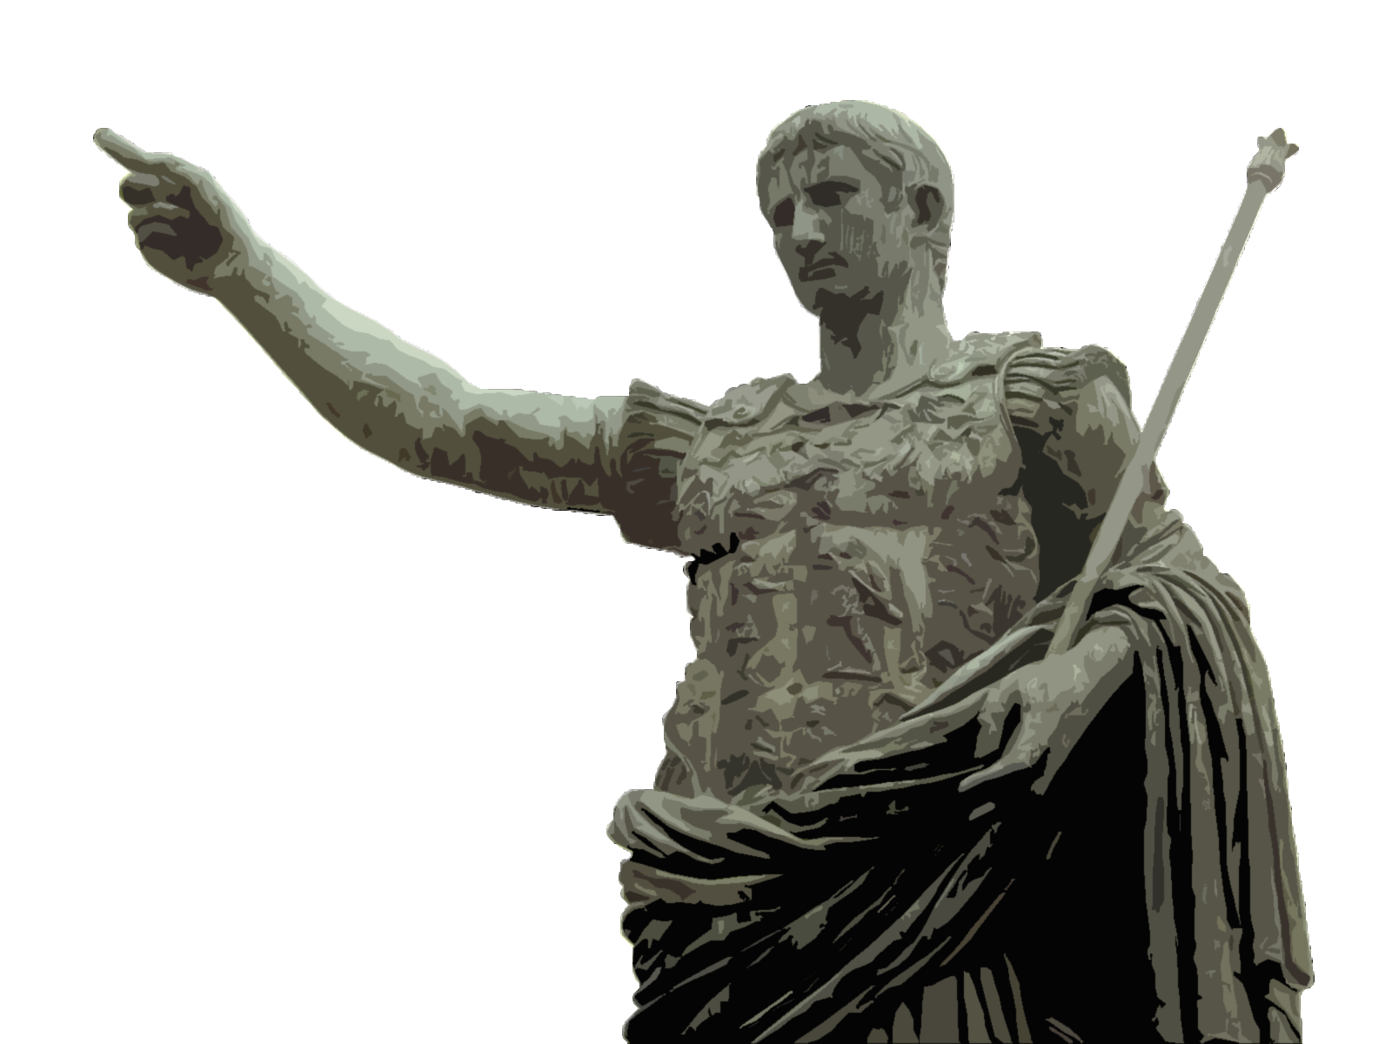

R

ome's era as a monarchy ended in 509 B.C. with the overthrow of its seventh king, Lucius Tarquinius Superbus, whom ancient historians portrayed as cruel and tyrannical, compared to his benevolent predecessors. A popular uprising was said to have arisen over the rape of a virtuous noblewoman, Lucretia, by the king's son. Whatever the cause, Rome turned from a monarchy into a republic, a world derived from res publica, or "property of the people."

**The Early Republic**

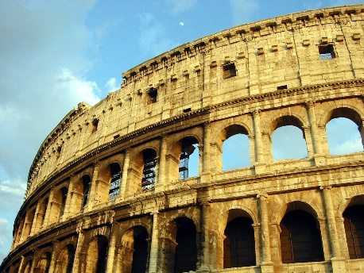The power of the monarch passed to two annually elected magistrates called consuls; they also served as commanders in chief of the army. The magistrates, though elected by the people, were drawn largely from the Senate, which was dominated by the patricians, or the descendants of 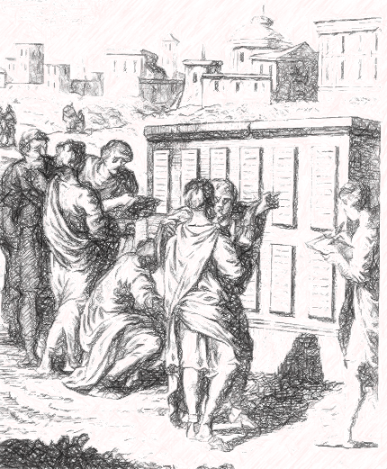the original senators from the time of Romulus. Politics in the early republic was marked by the long struggle between patricians and plebeians (the common people), who eventually attained some political power through years of concessions from patricians, including their own political bodies, the tribunes, which could initiate or veto legislation.

In 450 B.C., the first Roman law code was inscribed on 12 bronze tablets–known as the Twelve Tables–and publicly displayed in the Roman Forum. These laws included issues of legal procedure, civil rights and property rights and provided the basis for all future Roman civil law. By around 300 B.C., real political power in Rome was centered in the Senate, which at the time included only members of patrician and wealthy plebeian families.

**Military Expansion**

During the early republic, the Roman state grew exponentially in both size and power. Though the Gauls sacked and burned Rome in 390 B.C., the Romans rebounded under the leadership of the military hero Camillus, eventually gaining control of the entire Italian peninsula by 264 B.C. Rome then fought a series of wars known as the Punic Wars with Carthage, a powerful city-state in northern Africa. The first two Punic Wars ended with Rome in full control of Sicily, the western Mediterranean and much of Spain. In the Third Punic War (149–146 B.C.), the Romans captured and destroyed the city of Carthage and sold its surviving inhabitants into slavery, making a section of northern Africa a Roman province. At the same time, Rome also spread its influence east, defeating King Philip V of Macedonia in the Macedonian Wars and turning his kingdom into another Roman province.

Rome's military conquests led directly to its cultural growth as a society, as the Romans benefited greatly from contact with such advanced cultures as the Greeks. The first Roman literature appeared around 240 B.C., with translations of Greek classics into Latin; Romans would eventually adopt much of Greek art, philosophy and religion.

**Internal Struggles in the Late Republic**

Rome's complex political institutions began to crumble under the weight of the growing empire, ushering in an era of internal turmoil and violence. The gap between rich and poor widened as wealthy landowners drove small farmers from public land, while access to government was increasingly limited to the more privileged classes. Attempts to address these social problems, such as the reform movements of Tiberius and Gaius Gracchus (in 133 B.C. and 123-22 B.C., respectively) ended in the reformers' deaths at the hands of their opponents.

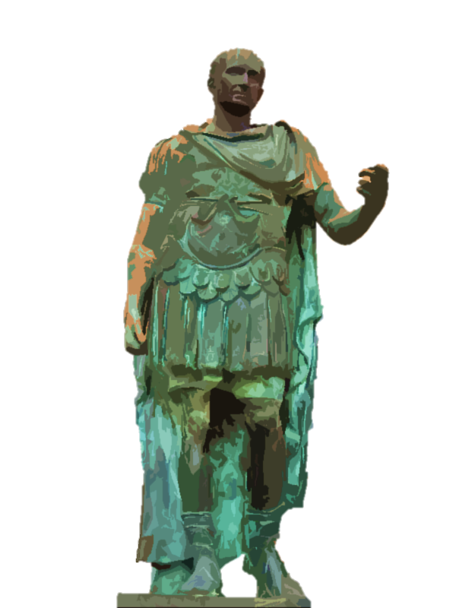Gaius Marius, a commoner whose military prowess elevated him to the position of consul (for the first of six terms) in 107 B.C., was the first of a series of warlords who would dominate Rome during the late republic. By 91 B.C., Marius was struggling against attacks by his opponents, including his fellow general Sulla, who emerged as military dictator around 82 B.C. After Sulla retired, one of his former supporters, Pompey, briefly served as consul before waging successful military campaigns against pirates in the Mediterranean and the forces of Mithridates in Asia. During this same period, Marcus Tullius Cicero, elected consul in 63 B.C., famously defeated the conspiracy of the patrician Cataline and won a reputation as one of Rome's greatest orators.

When the victorious Pompey returned to Rome, he formed an uneasy alliance known as the First Triumvirate with the wealthy Marcus Licinius Crassus (who suppressed a slave rebellion led by Spartacus in 71 B.C.) and another rising star in Roman politics: Gaius Julius Caesar. After earning military glory in Spain, Caesar returned to Rome to vie for the consulship in 59 B.C. From his alliance with Pompey and Crassus, Caesar received the governorship of three wealthy provinces in Gaul beginning in 58 B.C.; he then set about conquering the rest of the region for Rome.

After Pompey's wife Julia (Caesar's daughter) died in 54 B.C., and Crassus was killed in battle against Parthia (present-day Iran) the following year, the triumvirate was broken. With old-style Roman politics in disorder, Pompey stepped in as sole consul in 53 B.C. Caesar's military glory in Gaul and his increasing wealth had eclipsed Pompey's, and the latter teamed with his Senate allies to steadily undermine Caesar. In 49 B.C., Caesar and one of his legions crossed the Rubicon, a river on the border between Italy from Cisalpine Gaul. Caesar's invasion of Italy ignited a civil war from which he emerged as dictator of Rome for life in 45 B.C.